Flowchart Symbols

Start / Stop | Input / Output | Process | Decision

Flowchart 1 | Password Flowchart
Design a flowchart for a program which asks the user to enter a password. If the user enters “Yolo!” then print “Welcome”. If they enter a different password, print “Sorry, your password is incorrect” and end the program.

Flowchart 1 | Password Flowchart
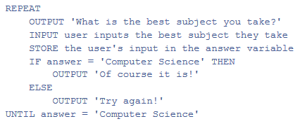

Mimic Name | Bridge Lights
SCREENSHOT HERE
Explanation Of Result

Mimic Name | Pelican Crossing
SCREENSHOT HERE
Explanation Of Result

Mimic Name | Robot
SCREENSHOT HERE
Explanation Of Result

Mimic Name | Level Crossing
SCREENSHOT HERE
Explanation Of Result

